**Problem to solve:**

People often like a brief overview of a country before they travel. This web site will give an overview of the state of a location at a glance, showing images, temperature, and so on.

**Why are we doing this:**

Technically “For school” is a correct answer, but that would be lazy English. I want to do this because I am interested in travelling someday. I am somewhat unsatisfied with the place I live as there is nothing to do in the city, and the weather is cold and harsh. I would like to be able to look at countries at a glance and see if I would want to visit/move.

**Who is the audience?**

While being a student I like to write programs that I would enjoy and might use. So first of all me, and second of all. Other like-minded people who are interested in one day traveling.

**List of functions:**

Display images()

Display Weather()

Country()

* Set
* Get

Display timezone()

Display from Json()

**Wireframes:**

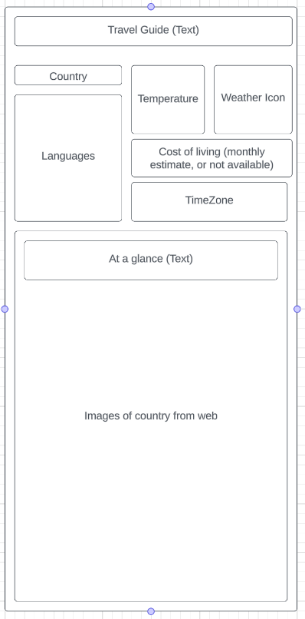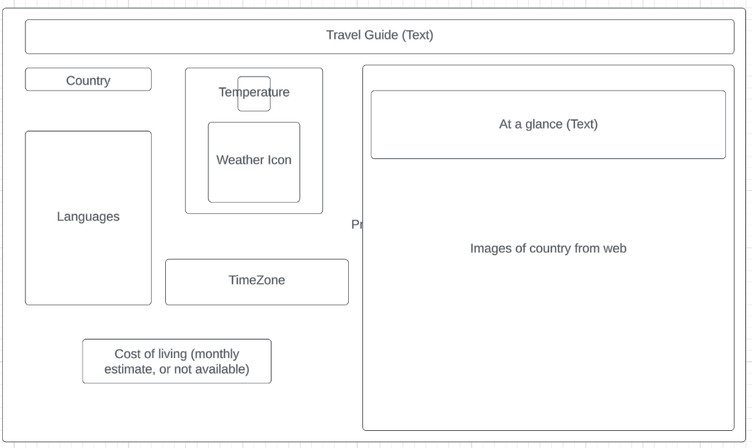

**Data sources:**

A Json file containing a list of counties, and potentially details about them.

Local storage recording what country the user was already looking at.

**Initial module list (elements)**

Header div

Country

Dropdown form element for the country (datalist?)

Temperature div

Temperature image

Weather div

Weather icon

Cost of living div (p element inside)

Time zone div (p element inside)

Images title div (p element inside)

Images div (images generated from web… is this possible?)

**Colors/Typography/specific element styling**

Primary/background (Seal brown): *#512002*

Primary/text (Electric blue): *#50ECFA*

Highlight 1 (Maize): *#FFF587*

Highlight 2 (OU crimson): *#8A0914*

Highlight 3 (Steel blue): #*0686d0*

**Schedule / mile markers**

* Make elements
* Write Text

**Link to a Trello board:**

<https://trello.com/invite/b/4vFnhQ5f/ATTI639584a57aa48cb4d9bf076305111a33BC1ED2EF/travel-guide>